**Sprint 1**

|  |  |
| --- | --- |
| Date | 10 November 2022 |
| Team ID | PNT2022TMID08883 |
| Project Name | Visualizing and Predicting Heart Diseases with an Interactive Dashboard |

**Uploading Heart disease Prediction Dataset Using Cognos Analysis: USN-1:**

* As a user, I can gather the details of the patients and store the data set.
* 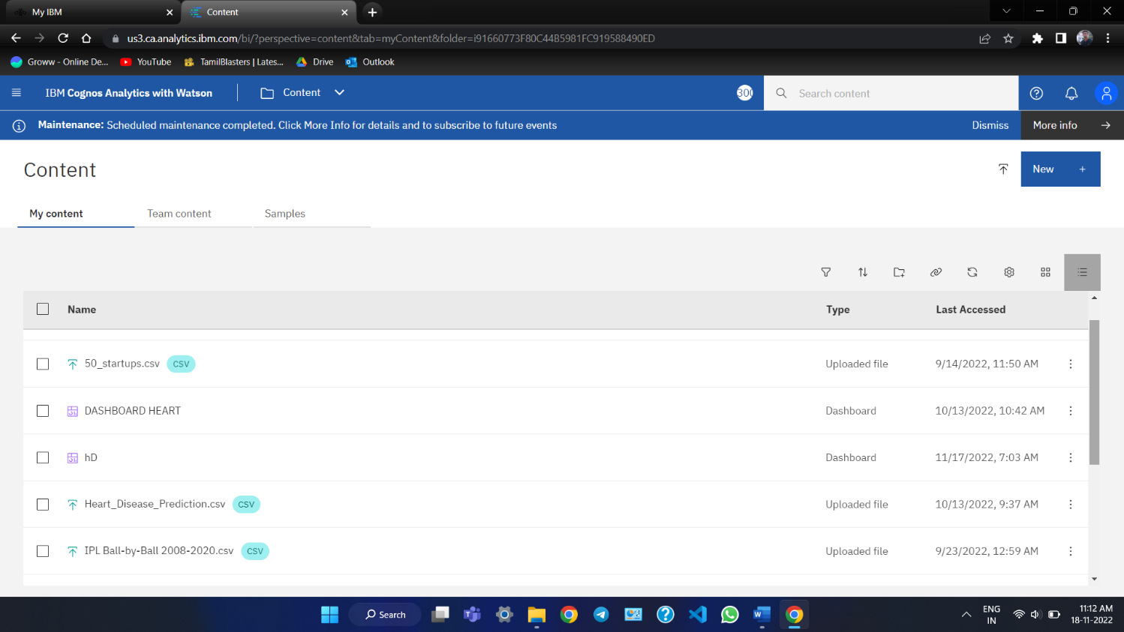Uploading the dataset of heart_disease_prediction.csv file to IBM Cognos Analytic

**Data Cleaning and Data Processing using Cognos Analytics: USN-2:**

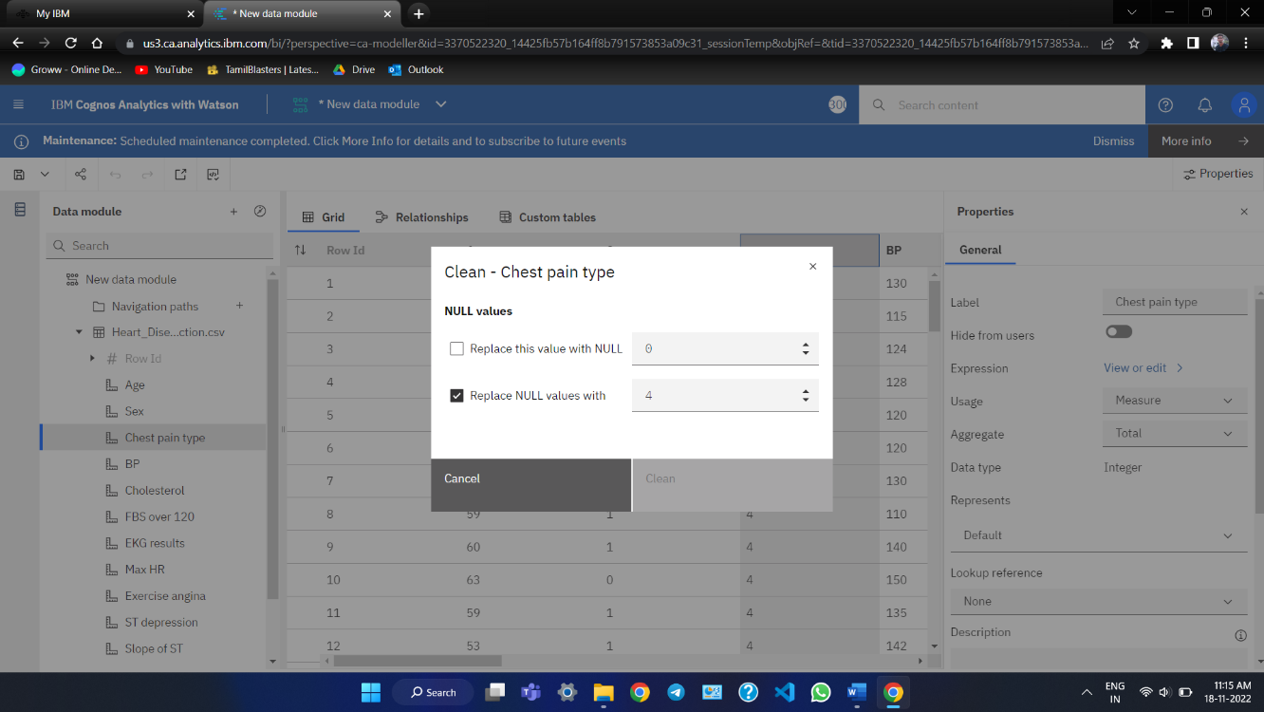

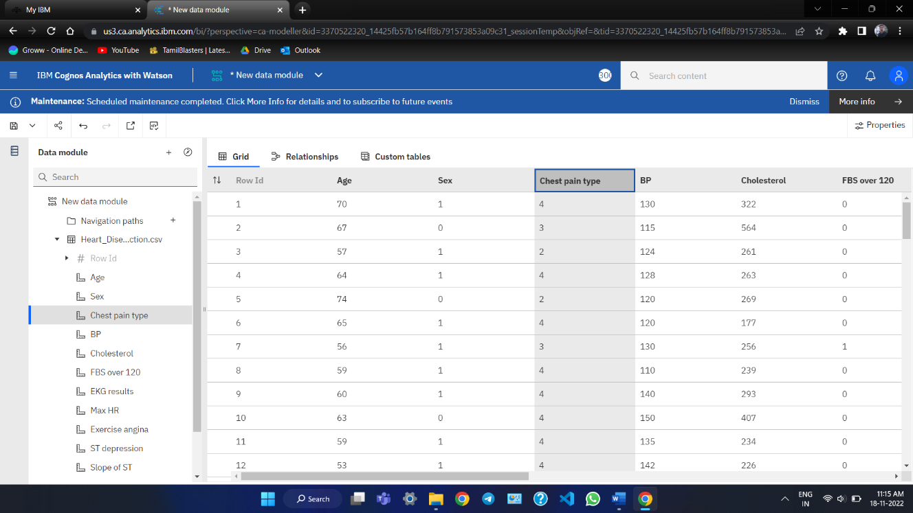

**Creating The Data Module using Cognos Analytics: USN-3:**

